**Optics with superior performances**

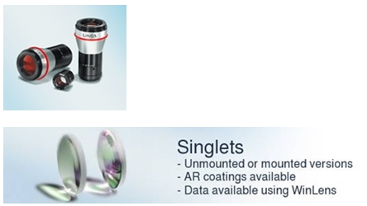

**Singlets**   
Reflection Curves of Coated Singlets   
Plano-Convex Lenses   
Symmetric-Convex Lenses   
Best Form Lenses   
Concave-Convex Lenses   
Plano-Concave Lenses   
Symmetric-Concave Lenses   
Cylindrical Lenses   
Aspheric Condenser Lenses   
Gradient Index (GRIN) Lenses   
Microlens Arrays   
Varioptic

* Operating mode of liquid lenses
* Liquid Lenses
* Driverboards
* Liquid Lens Accessories
* Developers Kits

  Minimal chromatic and spherical aberration

* Minimal wavefront-distorsionVery tight tolerances of focal lengths (+/- 1 %)
* Made of high-quality glasses
* Tight mechanical tolerances (diameter, centering, center thickness...)
* Tight optical tolerances (surface quality, accuracy...)

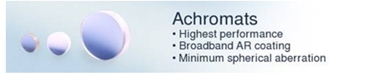  
**Achromats**   
Achromats, Positive   
Achromats, Negative   
Condensers   
  
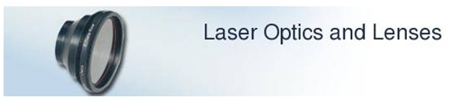  
**Laser Optics and Lenses**   
F-Theta-Ronar Lenses   
Beam Expanders

* Variable Beam Expanders
* Modular Beam Expanders
* Fixed Beam Expanders

Laser Beam Homogenizer   
High Aperture Laser Objectives (HALOs)   
Laser Diode Lenses   
  
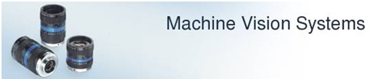  
**Machine Vision Systems**   
http://www.schmidt.com.tw/EN/EIE_Lasers_LINOS_OPTICS_clip_image005.gifMachine Vision Lenses   
Mechanical Accessories   
Optem Zoom Lens Systems

* Optem Micro Zoom Lens System
* Optem Macro Video Zoom Lens

Measuring Telescopes   
Autocollimators   
Compact Lenses   
MachVis Software   
  
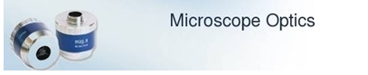  
**Microscope Optics**   
Microscope Objectives

* Infinity-Corrected Objectives
* Reflecting Objective mag.x R RO 20x / 0.35

Eyepieces

* Kellner eyepiece

Erfle / Orthoscopic eyepieces   
  
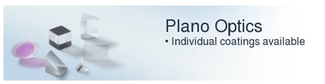  
**Plano Optics**   
http://www.schmidt.com.tw/EN/EIE_Lasers_LINOS_OPTICS_clip_image005_0000.gifPlane Plates   
Sapphire windows   
Prisms

* Reflection Prisms
* Dispersion Prisms
* Prism Corner Cubes

Filters   
Beamsplitter   
Reticles/Test Targets   
Dispersion Plates