LINOS – Mechanics  
High precision opto mechanics for optimal integration of optics

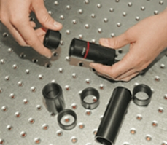  
Microbench

Nanobench

Tube Mounting System C

Macrobench

Positioning Systems

Profile and Rail Systems

Mounts, Posts and Holders

Lees and Mirror Mounts

Optical Tables

Light Sources and Laser

Spectrometer

Inspection Camera

